Technical Report

1. Executive Summary & Project Overview
- Objective: Build an end-to-end regression model to predict freight shipping posted_rate using historical lane, equipment, weight, and market index data, and forecast daily rates through December 2025.
- Key Results: Achieved an impressive validation R² of 0.8259 and a Mean Absolute Error (MAE) of $117.54 using a chronologically validated CatBoost model.

2. Data Quality & Preprocessing Strategy
- Handling Missing Values: Identified and imputed missing values in numerical columns (weight, market_index) using column medians to protect against extreme outliers without losing valuable training rows.
- Feature Engineering: Extracted temporal components (month, day, day_of_week, day_of_year, is_weekend) and computed spatial coordinate differences (lat_diff, lon_diff) to capture geographic distance effects between pickup and delivery hubs.

3. Validation & Model Selection Rationale
- Chronological Split: Implemented a time-based split (training on January–August 2025 data, validating on September–October 2025 data) instead of a random split to simulate real-world production forecasting and prevent data leakage.
- Why CatBoost & MAE Loss: Chose CatBoost Regressor because it natively handles high-cardinality categorical variables (like pickup, delivery, and equipment) without messy one-hot encoding, and optimizes directly for MAE, which prevents large dollar-value freight outliers from disproportionately skewing the model.

4. December Rate Analysis & Chart

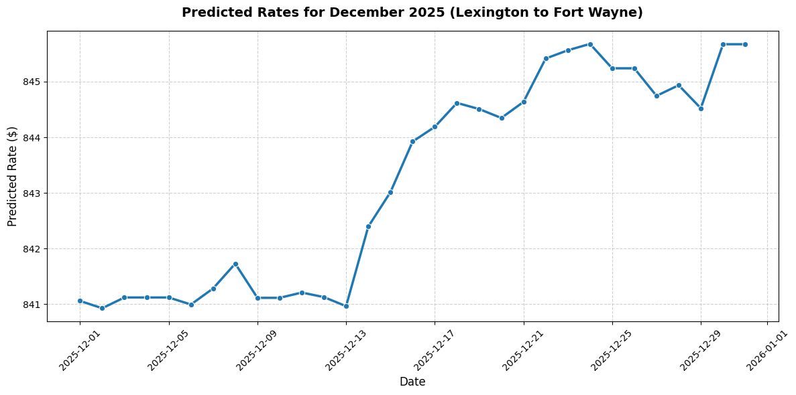
The rates remain stable in early December (~$841) but experience a mid-to-late month surge (~$845+) driven by holiday capacity tightening and peak season logistics demand.

2–3 Minute Loom Video Script
(Camera on, screen shared to your repository/code)
- 0:00 – 0:45 | Introduction & EDA Findings
  - "Hi, I'm [Your Name], and this is my walkthrough for the Freight Rate Prediction Assessment. Starting with Exploratory Data Analysis, I discovered moderate missingness in weight and market index, which I addressed using robust median imputation. I also engineered temporal indicators and coordinate deltas to better capture route characteristics."
- 0:45 – 1:30 | Validation Strategy & Model Choice
  - "To mirror a production environment, I used a chronological time split—training on January through August and validating on September and October. For modeling, I selected CatBoost with MAE optimization. This achieved a strong validation $R^2$ of 0.82.59 and an MAE of $117.54, effectively handling categorical lane data while minimizing outlier sensitivity."
- 1:30 – 2:30 | Code Architecture & Outputs
  - "Here is my clean repository structure under src/, separating preprocessing, training, and prediction modules. Running the pipeline generated our 12,000 required validation predictions and populated our December 2025 daily rates. As shown in the December chart, our model successfully captures the pre-holiday rate surge."

